EXPERIMENT NO. 5
Reconnaissance using Google & Who.is

Tool Used | Google Chrome, who.is

Platform | Windows Operating System

Target Domain | www.saveetha.com
AIM
To perform passive reconnaissance on a target domain using Google search and the who.is website, and to gather WHOIS registration details, DNS records, and network diagnostics.
TOOLS REQUIRED
- A system with internet access
- Google Chrome (or any web browser)
- who.is website (https://who.is)
THEORY
Reconnaissance is the first phase of ethical hacking, where information about a target is collected without directly interacting with its systems. Google and WHOIS lookup services like who.is are powerful passive reconnaissance tools — they reveal domain registration details, name servers, DNS records, and administrative contacts, all of which help an attacker (or a defender) understand the target's external footprint before any active scanning begins.
PROCEDURE
Step 1: In the Windows operating system, open Google Chrome and search for the who.is website.
Step 2: On the who.is website, enter the target domain name: www.saveetha.com.
Step 3: Review the WHOIS information, DNS records, and diagnostics (Ping and Traceroute) tabs to gather details about the website.
INFORMATION GATHERED
Information Category | Details Obtained
Registrar Info | Registrar name, WHOIS server, referral URL, domain status
Important Dates | Domain registration date, last updated date, expiry date
Name Servers | Authoritative name servers and their IP addresses
DNS Records | A, NS, SOA and MX records of the domain
Diagnostics | Ping response time and traceroute hop path to the server
OUTPUT
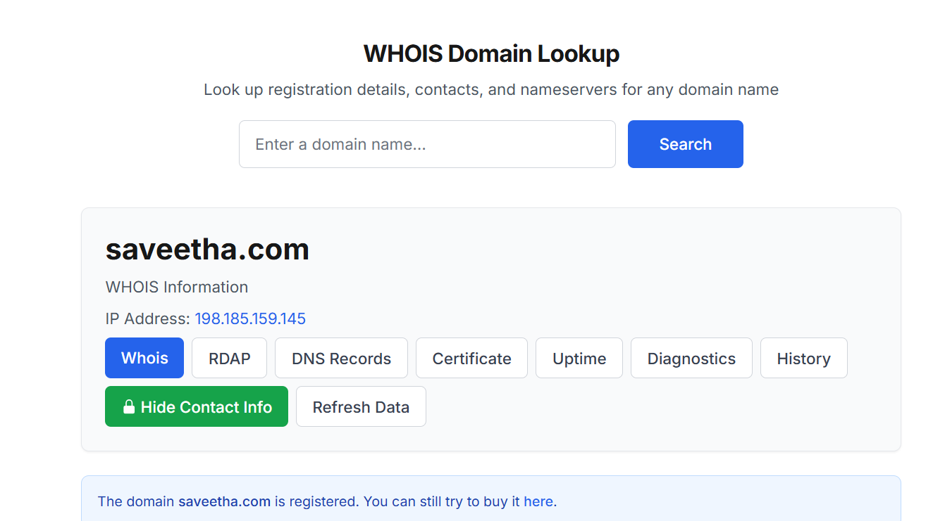

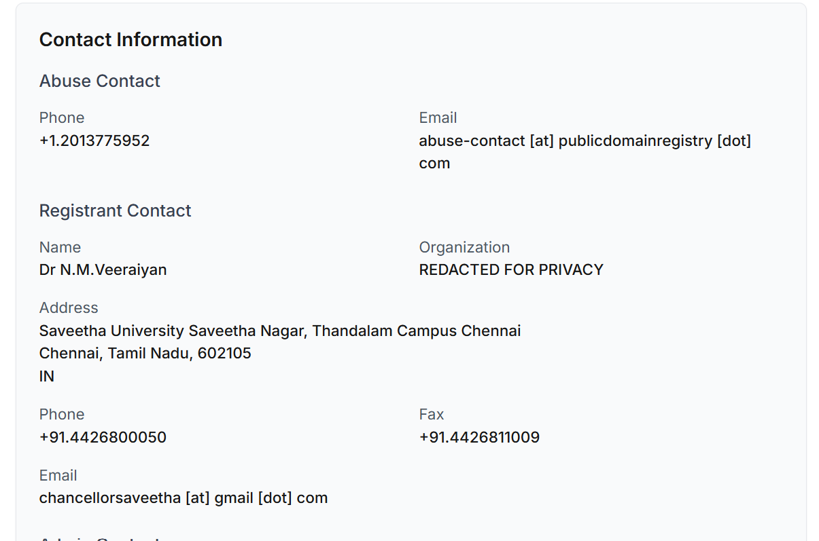

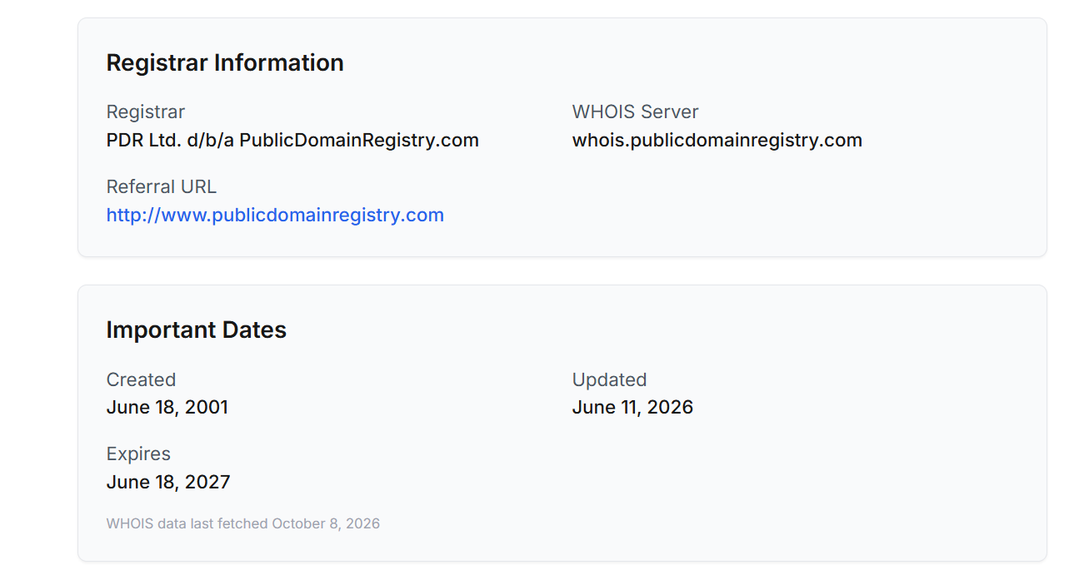

RESULT
Thus, reconnaissance on the target domain www.saveetha.com was successfully performed using Google and the who.is website, and the registrar, DNS, and diagnostic information of the website were obtained.

